Uşak is a small city in the West of Turkey.

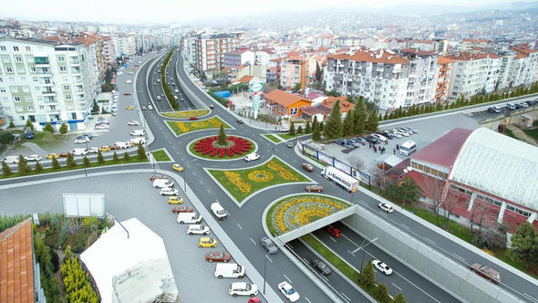

It has 5 districts:Eşme,Ulubey,Karahallı,Sivaslıand Banaz

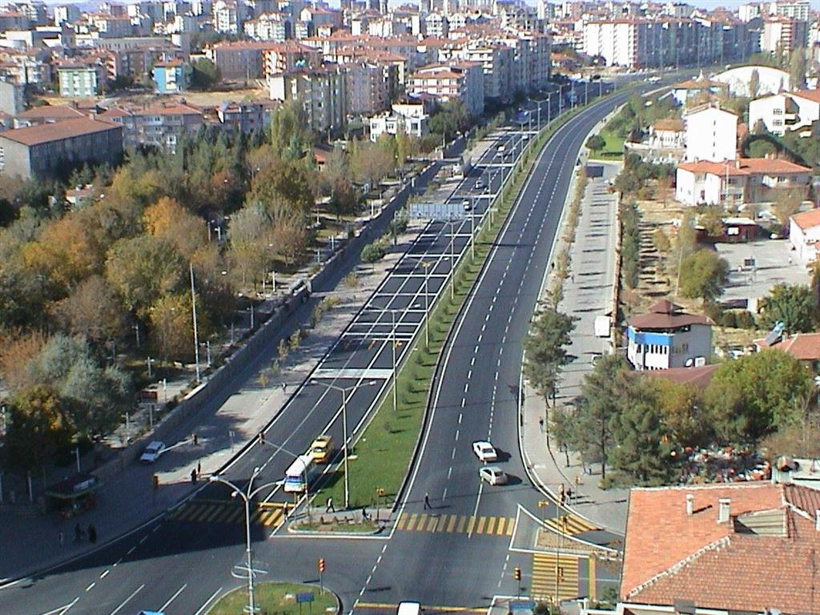

It is famous for tarhana soup, blanket, carpets

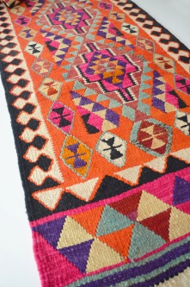

It is also famous for its canyons.Ulubey Canyons are the second greatest canyons of the World.
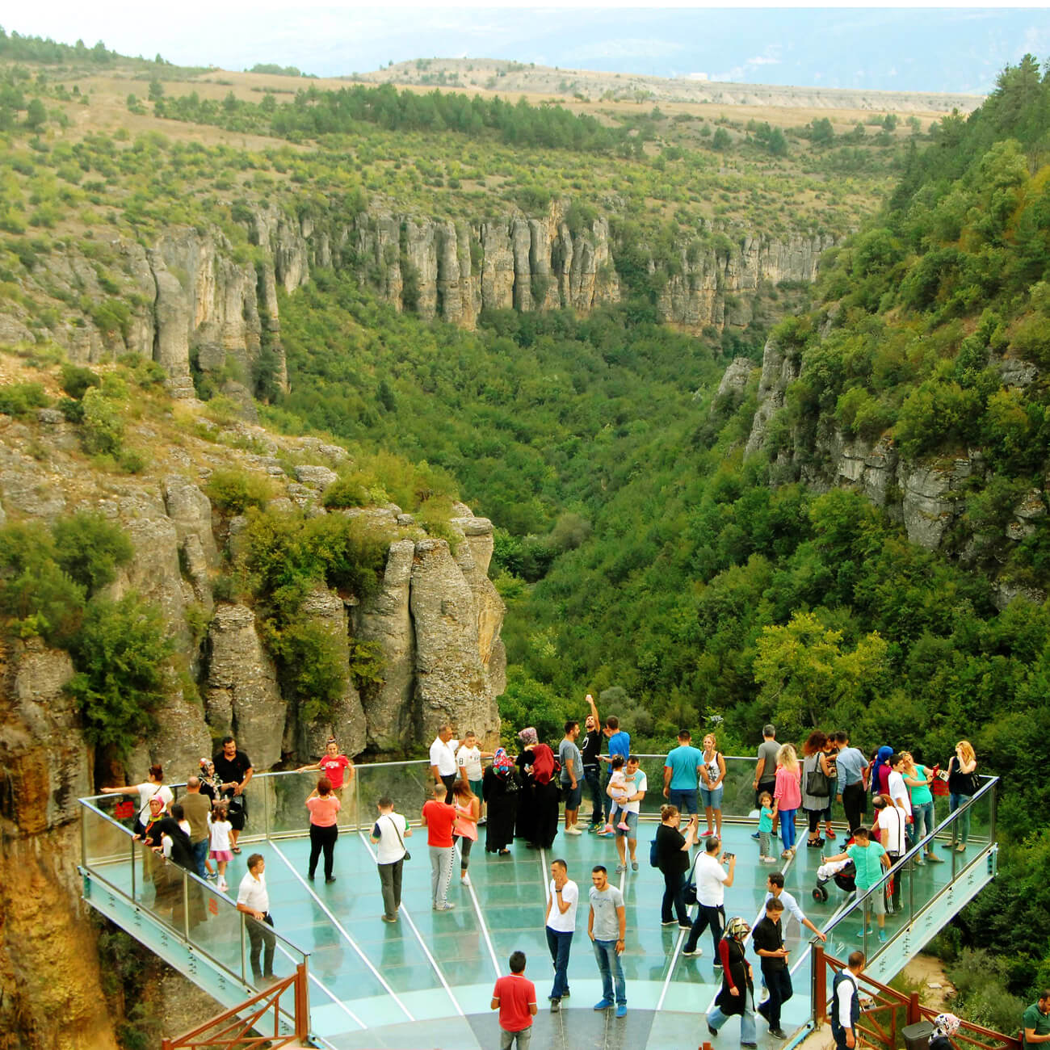

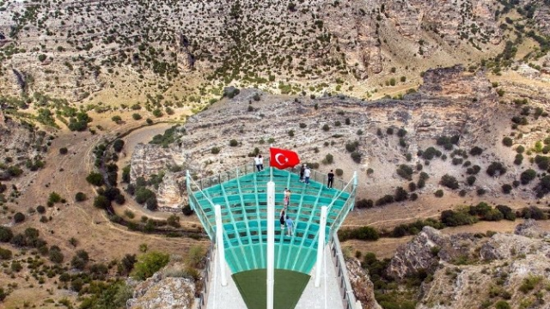

There are many historical mosques in Usak .One of them is Ulu Cami which dates back to OttomanEmpire
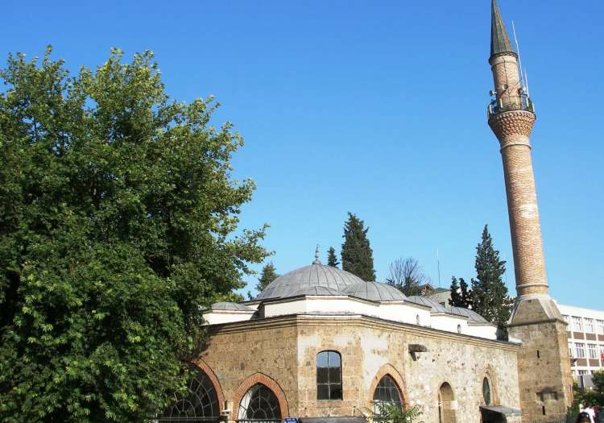

Clandıras Bridge is an ancient bridge to see and there is a large picnic area arou thebridge to have good time with family and friends

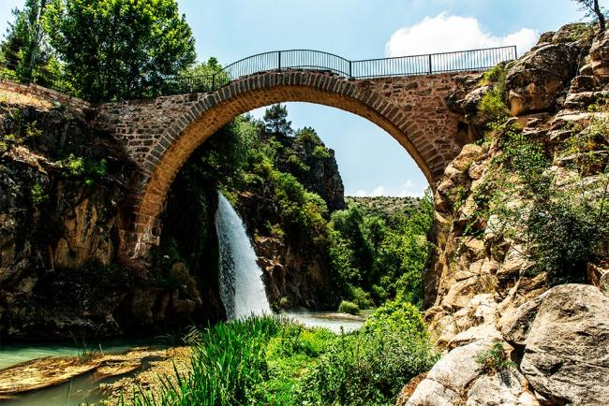

Blaundus Ancient City and Akmonia Ancient City are some of the historical places to visit

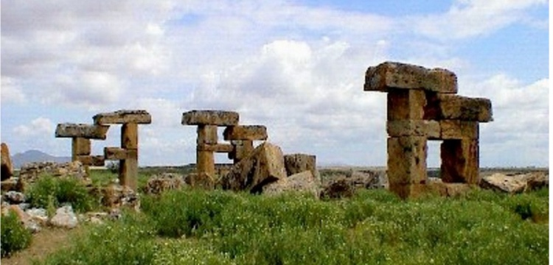

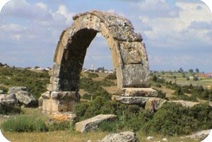

The monumental tree in Banaz worths tosee.It is 11 metres tall .Is thought to be around 500 to 1000 years old.

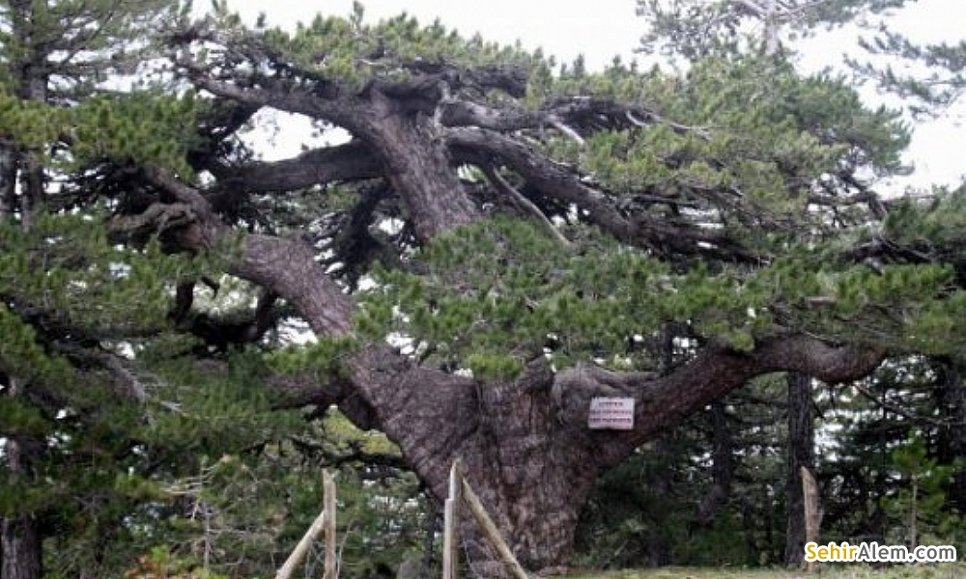

There are also hot springs in Usak.One of them is Hamambogazı in Banaz.You can benefit from this healthy water by swimming in it with friends.
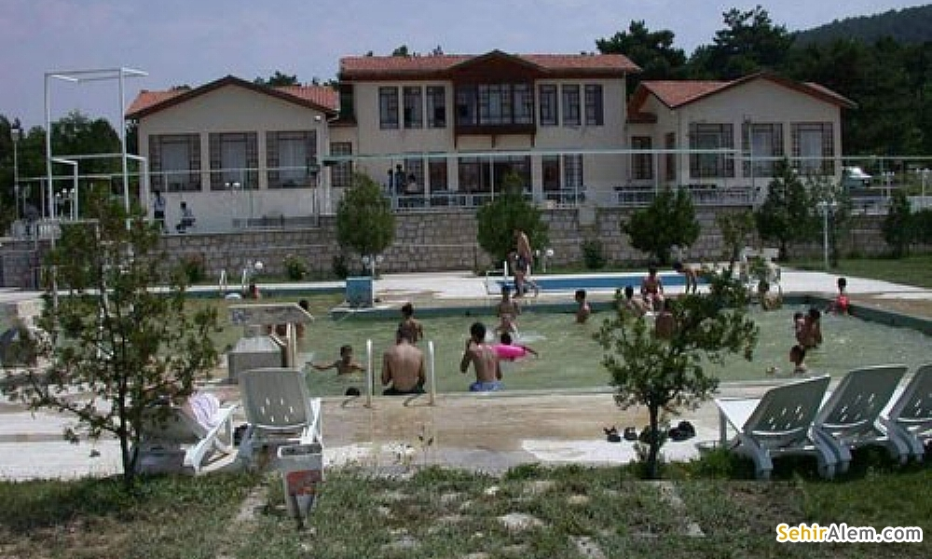
Usak is also famous for the sports javelin. It is an ancestor sport of us.You can watch the competitions of javelin in Uşak.

